FIRST ANNOUNCEMENT
2026 Molecular Chirality Asia Symposium (MCASIA2026)
Chirality is one of the essential attributes of nature and is profoundly interwoven with the origin and evolution of life. With the continuous advancement of chirality science, related theories and technologies have been widely applied and have contributed to many frontier fields, including chemistry, biomedicine, materials science, physics, and environmental engineering.
Since its first edition in Fukuoka, Japan, in 2012, the Molecular Chirality Asia Symposium has been held biennially and has successfully completed seven editions. The 2026 Molecular Chirality Asia Symposium (MCASIA2026) will be hosted by the Institute of Chemistry, Chinese Academy of Sciences, and Lanzhou University, and organized by the State Key Laboratory of Natural Products Chemistry, the College of Chemistry and Chemical Engineering of Lanzhou University, the Key Laboratory of Colloid, Interface and Chemical Thermodynamics, Chinese Academy of Sciences, the Key Laboratory of Molecular Recognition and Selective Synthesis, Chinese Academy of Sciences, and JASCO Corporation. It will be held from October 9 to 12, 2026, in Dunhuang, Gansu, China, famous city on the Silk Road.
The symposium will cover a broad range of topics, including chiral molecules, chiral supramolecules, asymmetric synthesis and catalysis, chiral nanomaterials, spectroscopy and structure, computational chemistry, functions and new mechanisms of chiral structures in physical, chemical and biological reactions, as well as exploration of the origin of chirality, among other frontier areas. We sincerely invite experts and scholars from related fields at home and abroad to attend the symposium and to promote the further development of molecular chirality research.
The detailed information is as follows:

1. ORGANIZERS
Hosts:
Institute of Chemistry, Chinese Academy of Sciences; Lanzhou University
Organizers:
State Key Laboratory of Natural Products Chemistry; College of Chemistry and Chemical Engineering, Lanzhou University; Key Laboratory of Colloid, Interface and Chemical Thermodynamics, Chinese Academy of Sciences; Key Laboratory of Molecular Recognition and Selective Synthesis, Chinese Academy of Sciences; JASCO Corporation
Conference Chairmen: Liu Minghua, Wang Wei
Executive Chairman: Zhang Haoli
Conference Secretaries: Zhang Li, Zhu Xuefeng, Feng Jie, Zhang Jiarui
Organizing Committee:
Chen Yu, Ding Sanyuan, Duan Yingying, Fan Junhua, Feng Jie, Guan Xiujuan, He Lipeng, Huo Yong, Ma Yu, Meng Qinggang, Sun Bing, Sun Wenjing, Song Nan, Su Pingru, Tang Jingrun, Wang Qi, Wei Shiqiang, Wen Xiuhong, Xi Pinxian, Zhang Haoli, Zhang Li, Zhang Jiarui, Zhang Jian, Zhu Xuefeng

2. DATE AND VENUE
Date: October 9–12, 2026 (Registration on October 9)
Venue: Tianhe Hotel, Tianhe Industrial Co., Ltd., Dunhuang, Gansu, China
(No. 106 Mingshan Middle Road, Dunhuang, Jiuquan, Gansu, China)

3. SYMPOSIUM TOPICS
The symposium will focus on frontier areas in chirality chemistry, including but not limited to:
- Chiral molecules and supramolecules
- Asymmetric synthesis and catalysis
- Chiral aggregates and functional materials
- Functions and mechanisms of chiral structures in physical, chemical, and biological reactions
- Origin of chirality and interdisciplinary frontiers

4. LANGUAGE
English

5. PRESENTATION FORMATS
The symposium will feature plenary lectures, keynote lectures, invited lectures, and poster presentations.

6. ABSTRACT SUBMISSION
Deadline: September 10, 2026
Abstracts should be submitted via the symposium website: https://mcasia2026.arkmeeting.com/
Please go to the “Abstract Submission” section on the website; the abstract template can be downloaded there.
All submitted abstracts will be compiled into a proceedings volume for exchange among participants.

7. REGISTRATION AND FEES
A registration fee will be charged. Transportation and accommodation expenses are to be borne by participants.
Registration fees:
Category | Before September 10 | After September 10
Faculty | 2000 RMB/person | 2400 RMB/person
Student | 1200 RMB/person | 1400 RMB/person
After September 30, the online registration system will be closed; on-site registration will be required at the rates of 2400 RMB/person for faculty and 1400 RMB/person for students.
Participants are requested to register and pay via the conference website link (https://mcasia2026.arkmeeting.com/) before September 10, 2026. Detailed information about the conference website will be provided in the second circular.
The registration fee will be collected by Gansu Hengyuexing Conference Service Co., Ltd., which will issue a unified VAT ordinary invoice and send it to participants via email.
Account Name: Gansu Hengyuexing Conference Service Co., Ltd.
Account Number: 2703002709200065815
Bank: Industrial and Commercial Bank of China Limited, Lanzhou Yongchang Road Sub-branch
Tax ID: 91620102MACW102C4P
Payment Contact: Chen Xuan, 13909406511
Note: We recommend using the QR code payment method and including the note “MCASIA2026 + Your Name” when making payment. The payment QR code and invoice QR code are shown below:
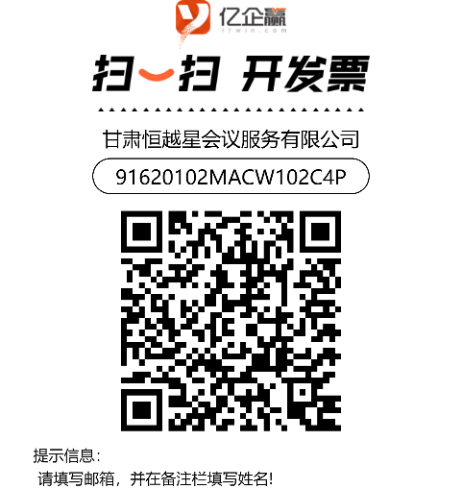

8. HOTEL INFORMATION
Tianhe Hotel, Tianhe Industrial Co., Ltd., Dunhuang, Gansu, China
No. 106 Mingshan Middle Road, Dunhuang, Jiuquan, Gansu, China
Room Type | Reference Price (RMB)
Deluxe Twin Room | 450
Deluxe King Room | 450
Light Luxury Twin Room | 380
Suite | 980
The above rates are in RMB and include breakfast for up to two persons per room. If breakfast is not included in the room rate, it can be purchased separately at 68 RMB/person. Hotel accommodation fees shall be settled by participants directly with the hotel.

